**Results for ML model training over HMM data**

**Bayesian Network**

|  |  |  |  |  |  |  |
| --- | --- | --- | --- | --- | --- | --- |
|  |  | **Classification** | | | | |
|  | **Class** | Happy | Interested | Sad | Worried | Stern |
| **True Class** | Happy | 45 | 17 | 0 | 0 | 0 |
| Interested | 29 | 88 | 0 | 7 | 0 |
| Sad | 0 | 3 | 0 | 6 | 0 |
| Worried | 0 | 3 | 0 | 22 | 0 |
| Stern | 0 | 2 | 0 | 12 | 0 |

Correctly Classified Instances 155 66.2393 %

Incorrectly Classified Instances 79 33.7607 %

**Naïve Bayes**

|  |  |  |  |  |  |  |
| --- | --- | --- | --- | --- | --- | --- |
|  |  | **Classification** | | | | |
|  | **Class** | Happy | Interested | Sad | Worried | Stern |
| **True Class** | Happy | 39 | 23 | 0 | 0 | 0 |
| Interested | 26 | 86 | 6 | 6 | 0 |
| Sad | 0 | 6 | 1 | 2 | 0 |
| Worried | 0 | 2 | 3 | 18 | 2 |
| Stern | 0 | 2 | 0 | 10 | 2 |

Correctly Classified Instances 146 62.3932 %

Incorrectly Classified Instances 88 37.6068 %

**Logistic regression**

|  |  |  |  |  |  |  |
| --- | --- | --- | --- | --- | --- | --- |
|  |  | **Classification** | | | | |
|  | **Class** | Happy | Interested | Sad | Worried | Stern |
| **True Class** | Happy | 40 | 22 | 0 | 0 | 0 |
| Interested | 27 | 91 | 0 | 6 | 0 |
| Sad | 0 | 6 | 0 | 3 | 0 |
| Worried | 0 | 4 | 0 | 20 | 1 |
| Stern | 0 | 2 | 0 | 10 | 2 |

Correctly Classified Instances 153 65.3846 %

Incorrectly Classified Instances 81 34.6154 %

**Multilayer Perceptron / Neural net, one layer**

|  |  |  |  |  |  |  |
| --- | --- | --- | --- | --- | --- | --- |
|  |  | **Classification** | | | | |
|  | **Class** | Happy | Interested | Sad | Worried | Stern |
| **True Class** | Happy | 37 | 25 | 0 | 0 | 0 |
| Interested | 26 | 91 | 1 | 6 | 0 |
| Sad | 0 | 6 | 1 | 2 | 0 |
| Worried | 0 | 3 | 2 | 15 | 5 |
| Stern | 0 | 2 | 0 | 7 | 5 |

Correctly Classified Instances 149 63.6752 %

Incorrectly Classified Instances 85 36.3248 %

**K-nearest neighbors (1 neighbor, performance degrades with more neighbors)**

|  |  |  |  |  |  |  |
| --- | --- | --- | --- | --- | --- | --- |
|  |  | **Classification** | | | | |
|  | **Class** | Happy | Interested | Sad | Worried | Stern |
| **True Class** | Happy | 41 | 21 | 0 | 0 | 0 |
| Interested | 29 | 88 | 1 | 6 | 0 |
| Sad | 0 | 6 | 2 | 1 | 0 |
| Worried | 0 | 5 | 2 | 14 | 4 |
| Stern | 0 | 2 | 0 | 10 | 2 |

Correctly Classified Instances 147 62.8205 %

Incorrectly Classified Instances 87 37.1795 %

**Random Forest**

|  |  |  |  |  |  |  |
| --- | --- | --- | --- | --- | --- | --- |
|  |  | **Classification** | | | | |
|  | **Class** | Happy | Interested | Sad | Worried | Stern |
| **True Class** | Happy | 43 | 19 | 0 | 0 | 0 |
| Interested | 29 | 88 | 1 | 6 | 0 |
| Sad | 0 | 3 | 3 | 3 | 0 |
| Worried | 0 | 3 | 2 | 15 | 5 |
| Stern | 0 | 2 | 0 | 10 | 2 |

Correctly Classified Instances 151 64.5299 %

Incorrectly Classified Instances 83 35.4701 %

**SVM (linear kernel)**

|  |  |  |  |  |  |  |
| --- | --- | --- | --- | --- | --- | --- |
|  |  | **Classification** | | | | |
|  | **Class** | Happy | Interested | Sad | Worried | Stern |
| **True Class** | Happy | 45 | 17 | 0 | 0 | 0 |
| Interested | 29 | 89 | 0 | 6 | 0 |
| Sad | 0 | 5 | 0 | 4 | 0 |
| Worried | 0 | 4 | 0 | 21 | 0 |
| Stern | 0 | 2 | 0 | 12 | 0 |

Correctly Classified Instances 155 66.2393 %

Incorrectly Classified Instances 79 33.7607 %

**SVM (polynomial kernel)**

|  |  |  |  |  |  |  |
| --- | --- | --- | --- | --- | --- | --- |
|  |  | **Classification** | | | | |
|  | **Class** | Happy | Interested | Sad | Worried | Stern |
| **True Class** | Happy | 44 | 18 | 0 | 0 | 0 |
| Interested | 29 | 88 | 1 | 6 | 0 |
| Sad | 0 | 6 | 0 | 3 | 0 |
| Worried | 0 | 5 | 0 | 15 | 5 |
| Stern | 0 | 2 | 0 | 9 | 3 |

Correctly Classified Instances 150 64.1026 %

Incorrectly Classified Instances 84 35.8974 %

**SVM (radial kernel)**

|  |  |  |  |  |  |  |
| --- | --- | --- | --- | --- | --- | --- |
|  |  | **Classification** | | | | |
|  | **Class** | Happy | Interested | Sad | Worried | Stern |
| **True Class** | Happy | 41 | 21 | 0 | 0 | 0 |
| Interested | 28 | 89 | 0 | 7 | 0 |
| Sad | 0 | 6 | 0 | 3 | 0 |
| Worried | 0 | 5 | 0 | 20 | 0 |
| Stern | 0 | 2 | 0 | 11 | 1 |

Correctly Classified Instances 151 64.5299 %

Incorrectly Classified Instances 83 35.4701 %

**SVM (sigmoid kernel)**

|  |  |  |  |  |  |  |
| --- | --- | --- | --- | --- | --- | --- |
|  |  | **Classification** | | | | |
|  | **Class** | Happy | Interested | Sad | Worried | Stern |
| **True Class** | Happy | 0 | 60 | 0 | 2 | 0 |
| Interested | 0 | 116 | 0 | 8 | 0 |
| Sad | 0 | 9 | 0 | 0 | 0 |
| Worried | 0 | 25 | 0 | 0 | 0 |
| Stern | 0 | 14 | 0 | 0 | 0 |

Correctly Classified Instances 116 49.5726 %

Incorrectly Classified Instances 118 50.4274 %

**Some things to note:**

* Figure 1 represents the visualization of the input data, which illustrates the disparity between the amount of data for ‘interested’ to all other emotions.

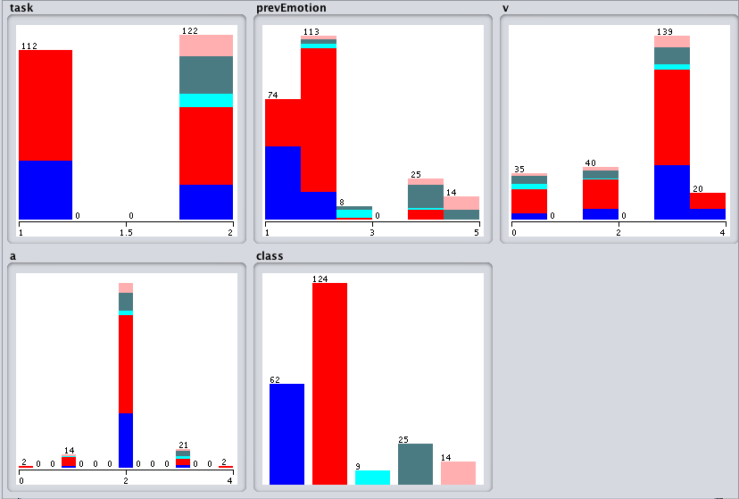

Figure 1: Distribution of input data